Update the [lawn_tractor](https://github.com/ros-agriculture/lawn_tractor/tree/develop)/[lawn_tractor_navigation](https://github.com/ros-agriculture/lawn_tractor/tree/develop/lawn_tractor_navigation)/**config**/ settings

Notes:

* <https://wiki.ros.org/teb_local_planner/Tutorials/Setup%20and%20test%20Optimization>

On the tractor RPI open /home/ubuntu/catkin_ws/src/lawn_tractor/lawn_tractor_navigation/config

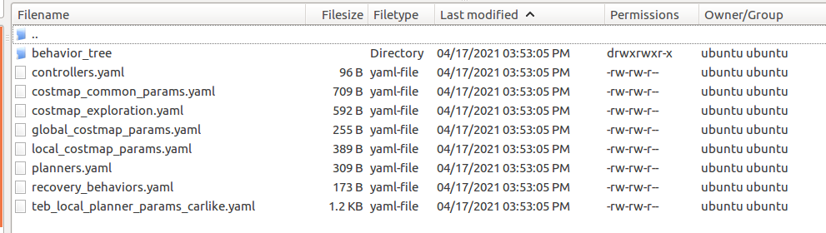

| **costmap_common_params.yaml** | **costmap_exploration.yaml** |
| --- | --- |
| # file: costmap_common_params.yaml  # # Make sure to preserve indentation if copied (for all yaml  # files)  footprint: [ [-0.125,0.125], [0.125,0.125], [0.125,-0.125],  [-0.125,-0.125] ]  transform_tolerance: 0.5  map_type: costmap  global_frame: map  robot_base_frame: base_link  obstacle_layer:  enabled: true  obstacle_range: 3.0  raytrace_range: 4.0  track_unknown_space: true  combination_method: 1  observation_sources: laser_scan_sensor  laser_scan_sensor: {data_type: LaserScan, topic: scan,  marking: true, clearing: true}  inflation_layer:  enabled: true  inflation_radius: 0.5  static_layer:  enabled: true | track_unknown_space: true  global_frame: map  rolling_window: false  plugins:  - {name: external, type: "costmap_2d::StaticLayer"}  - {name: explore_boundary, type: "frontier_exploration::BoundedExploreLayer"}  #Can disable sensor layer if gmapping is fast enough to update scans  - {name: obstacles_laser, type: "costmap_2d::ObstacleLayer"}  - {name: inflation, type: "costmap_2d::InflationLayer"}  explore_boundary:  resize_to_boundary: false  frontier_travel_point: middle  #set to false for gmapping, true if re-exploring a known area  explore_clear_space: false |
|  |  |
| **global_costmap_params.yaml** | **local_costmap_params.yaml** |
| # file: global_costmap_params.yaml  global_costmap:  update_frequency: 1.0  publish_frequency: 0.5  static_map: true  plugins:  - {name: static_layer, type: "costmap_2d::StaticLayer"}  # - {name: inflation_layer, type: "costmap_2d::InflationLayer"} | # file: local_costmap_params.yaml  local_costmap:  update_frequency: 5.0  publish_frequency: 2.0  static_map: false  rolling_window: true  width: 5.5 ## -> computation time: teb_local_planner  height: 5.5 # -> computation time: teb_local_planner  resolution: 0.1 # -> computation time: teb_local_planner  plugins:  - {name: obstacle_layer, type: "costmap_2d::ObstacleLayer"} |
|  |  |
| **planners.yaml** | **recovery_behaviors.yaml** |
| planners:  - name: 'GlobalPlanner'  type: 'global_planner/GlobalPlanner'  planner_patience: 5.0  planner_frequency: 1.0  GlobalPlanner:  allow_unknown: false  default_tolerance: 0.0  visualize_potential: true  use_dijkstra: true  use_quadratic: false  use_grid_path: false  old_navfn_behaviour: false | recovery_behaviors:  - name: 'rotate_recovery'  type: 'rotate_recovery/RotateRecovery'  - name: 'clear_costmap'  type: 'clear_costmap_recovery/ClearCostmapRecovery' |
|  |  |
| **teb_local_planner_params_carlike.yaml** |  |
| # file: teb_local_planner_params.yaml  TebLocalPlannerROS:  # Trajectory  teb_autosize: True  dt_ref: 0.3  dt_hysteresis: 0.1  global_plan_overwrite_orientation: True  allow_init_with_backwards_motion: False  max_global_plan_lookahead_dist: 3.0  feasibility_check_no_poses: 5  # Robot  max_vel_x: 2.0  min_vel_x: 0.0  max_vel_x_backwards: 1.0  max_vel_theta: 2.0  acc_lim_x: 2.5  acc_lim_theta: 2.5  min_turning_radius: 1.0 # diff-drive robot (can turn in place  wheelbase: 0.4  cmd_angle_instead_rotvel: True  weight_kinematics_turning_radius: 1.5 # increase of min_turning_radius is not enough  footprint_model:  type: "line" # include robot radius in min_obstacle_dist  line_start: [0.0, 0.0] # include robot expanse in min_obstical_dist  line_end: [0.4, 0.0]  # Goal Tolerance  xy_goal_tolerance: 0.4  yaw_goal_tolerance: 0.2    # Obstacles  min_obstacle_dist: 0.25  costmap_obstacles_behind_robot_dist: 1.0  obstacle_poses_affected: 10  # Optimization  no_inner_iterations: 5  no_outer_iterations: 4  optimization_activate: True  optimization_verbose: False |  |

* The turning radius, or *turning path*, of a vehicle is the smallest circular turn that it can make.
* A vehicle’s turning circle is the radius (or diameter) measured by the outer wheels of the vehicle while making a complete turn.



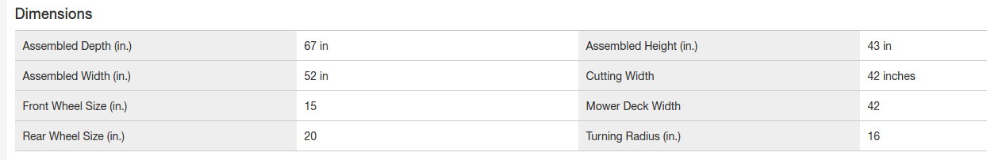

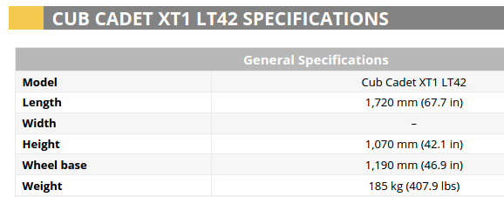

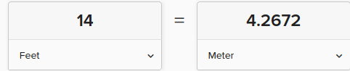

The diameter of the turning circle measured by the outer wheels of my lawn tractor while making a complete turn is ~13-14 feet. (~4-4.3 meters). I know this because I executed cmd_vel commands linear.x(speed) 0.8, angular.z(steer angle) -1.0 and +1.0 , distance (in meters) 80 and measured the results.

Wheelbase = 50 inches



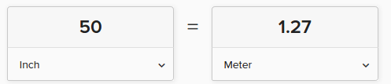

# GoalTolerance

xy_goal_tolerance: 1.0

yaw_goal_tolerance: 1.0

